**Experiment No :** 11

**Experiment name :** Write a C Program to find LCM of two numbers .

**Methodology :**

To find the Least Common Multiple (LCM) of two numbers in C, we can use the formula:

LCM(a, b) = (a * b) / GCD(a, b)

where GCD(a, b) is the Greatest Common Divisor of the two numbers. We can utilize the recursive GCD function we previously implemented to find the LCM.

**Flow-Chart :**

int num1 , num2 , max

**Code :**

LCM = max

Max++

Num1>num2?

Num1>num2?

Max = num1

Max = num2

scanf("%d %d",&num1 , &num2);

#include<stdio.h>

int main(){

int num1 , num2 , max ;

printf("Enter two possitive number : ");

scanf("%d %d",&num1 , &num2);

//maximum number between num1 and num2 is storde in max .

max = (num1 > num2) ? num1 : num2 ;

while(1){

if((max % num1 == 0) && (max % num2 == 0)){

printf("The LCM of %d and %d is %d", num1 , num2 , max);

break;

}

max++;

}

return 0 ;

}

**Output:**

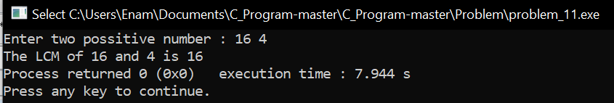

**Result discussion :**

1. The gcd_recursive function is the recursive GCD function we discussed earlier.
2. The lcm function calculates the LCM of two numbers a and b by first finding their GCD using the gcd_recursive function and then using the LCM formula.
3. In the main function, the user is prompted to enter two numbers.
4. The lcm function is called with the two input numbers to calculate their LCM.
5. The program then prints the LCM of the two input numbers.